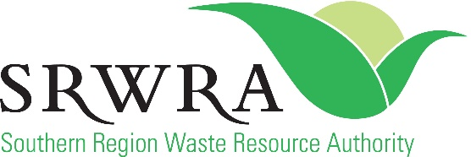

SRWRA School Recycled Art Competition 2021 – CONSENT FORM

Consent/Talent Release Form

I (please print name):………………………………………………………………………..agree to allow Southern Region Waste Resource Authority (SRWRA), and the Cities of Holdfast Bay, Marion and Onkaparinga to use my image (if supplied), audio and submitted material in the 2021 SRWRA School Recycled Art Competition which involves public access to this material online as well as program promotion and community education.
I understand and consent that the above organisations may:
- Use my image or audio and creative content as well as collaborative work (herein referred to as material);
- Publish this material online for public viewing following the competition and into the future;
- Use this material for program promotion, community education and engagement and;
- Use information gathered from the SRWRA School Recycled Art Competition 2021 submissions to discuss the project with media.

In signing this Consent form, I understand that:
- Any material supplied to me cannot be used for commercial purposes;
- The above organisations will not pay for any consent or for the use of my material (and/or material produced collaboratively);
- The above organisations may keep the material on record and may use this in the future unless I specify limitations in writing to SRWRA: info@srwra.com.au, and I can provide proof of this;
- Material uploaded online will become public content and;
- Material submitted must be appropriately acknowledged for any input, guidance and talent included in content.

Signature of parent/guardian of participant/s under 18 years of age:
Parent/Guardian name (please print): …………………………………............................................
Signature: ………………...………………………………….
Relationship to minor: ………………...………………………………….
Date: ………………...………………………………….

P.T.O.
Signature of participant/s if aged 18 or more:
Name: (please print) …………………………………............................................
Signature: ………………...………………………………….
Date: ………………...………………………………….

Participant’s contact details
Phone: ………………...………………………………….
Email: ………………...………………………………….
Address: …………………………………............................................
School/Educational Facility: ………………...………………………………….
School/Facility Contact name: ………………...………………………………….
School/Facility Contact phone: ………………...………………………………….
School/Facility Contact email: ………………...………………………………….

Your local Waste and Recycling Education Officer can be contacted via email:
- City of Holdfast Bay
Shani, on 0400 293 945 or SWood@holdfast.sa.gov.au
- City of Marion
Allison, on 0412 057 104 or Allison.Byrne@marion.sa.gov.au
- City of Onkaparinga
Lynda, on 0466 476 090 or Lynda.Wedding@onkaparinga.sa.gov.au
We endeavour to check emails regularly and respond as soon as possible however some enquiries may require consultation and therefore may be delayed slightly.
